SAVE A LIFE
30,000 Cardiac arrests occur every year in the UK
Less than 10% survive
Can you assess a casualty?
Can you do Cardio Pulmonary Resuscitation (CPR)?
Can you use an Automatic External Defibrillator (AED)?
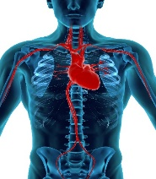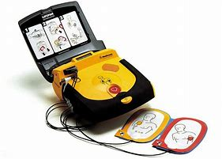
Village Hall
Tuesday 13th June
7.30 pm
Richard Bush has 22 years service in St John Ambulance and is a Certified First Aider
For further information contact 07960 791931
No Charge: Donations are welcome to pay expenses

